WEEK-4
Task 28: Implement Queue using Stacks:
import java.util.Stack;
class MyQueue {
Stack<Integer> inStack;
Stack<Integer> outStack;
public MyQueue() {
inStack = new Stack<>();
outStack = new Stack<>();
}
public void push(int x) {
inStack.push(x);
}
public int pop() {
peek();
return outStack.pop();
}
public int peek() {
if (outStack.isEmpty()) {
while (!inStack.isEmpty()) {
outStack.push(inStack.pop());
}
}
return outStack.peek();
}
public boolean empty() {
return inStack.isEmpty() && outStack.isEmpty();
}
}
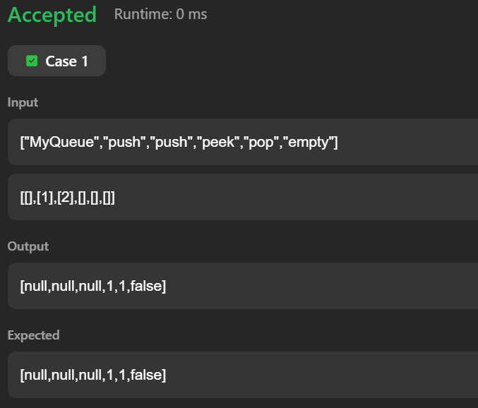

Task 29: Sliding Window Maximum:
class Solution {
public int[] maxSlidingWindow(int[] nums, int k) {
int n = nums.length;
int[] ans = new int[n - k + 1];
Deque<Integer> dq = new ArrayDeque<>();
for (int i = 0; i < n; i++) {
if (!dq.isEmpty() && dq.peekFirst() <= i - k) {
dq.pollFirst();
}
while (!dq.isEmpty() && nums[dq.peekLast()] < nums[i]) {
dq.pollLast();
}
dq.offerLast(i);
if (i >= k - 1) {
ans[i - k + 1] = nums[dq.peekFirst()];
}
}
return ans;
}
}

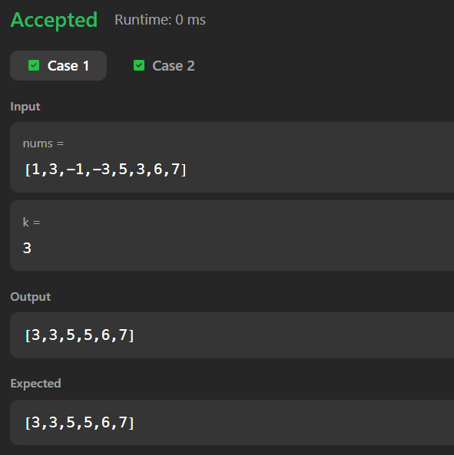
Task 30: Longest Continuous Subarray With Absolute Diff Less Than or Equal to Limit:

class Solution {
public int longestSubarray(int[] nums, int limit) {
Deque<Integer> maxD = new ArrayDeque<>();
Deque<Integer> minD = new ArrayDeque<>();
int left = 0, res = 0;
for (int right = 0; right < nums.length; right++) {
while (!maxD.isEmpty() && nums[maxD.peekLast()] < nums[right]) {
maxD.pollLast();
}
maxD.offerLast(right);
while (!minD.isEmpty() && nums[minD.peekLast()] > nums[right]) {
minD.pollLast();
}
minD.offerLast(right);
while (nums[maxD.peekFirst()] - nums[minD.peekFirst()] > limit) {
if (maxD.peekFirst() == left) maxD.pollFirst();
if (minD.peekFirst() == left) minD.pollFirst();
left++;
}
res = Math.max(res, right - left + 1);
}
return res;
}
}

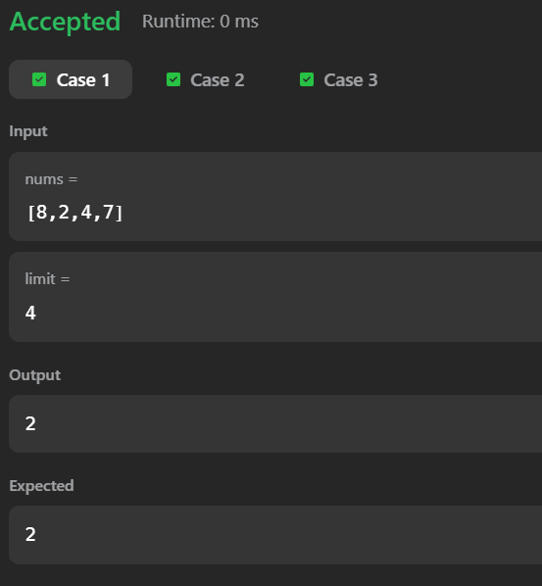
Task 31: Binary Tree Level Order Traversal:
class Solution {
public List<List<Integer>> levelOrder(TreeNode root) {
List<List<Integer>> res = new ArrayList<>();
if (root == null) return res;
Queue<TreeNode> q = new LinkedList<>();
q.offer(root);
while (!q.isEmpty()) {
int size = q.size();
List<Integer> level = new ArrayList<>();
for (int i = 0; i < size; i++) {
TreeNode node = q.poll();
level.add(node.val);
if (node.left != null) q.offer(node.left);
if (node.right != null) q.offer(node.right);
}
res.add(level);
}
return res;
}
}

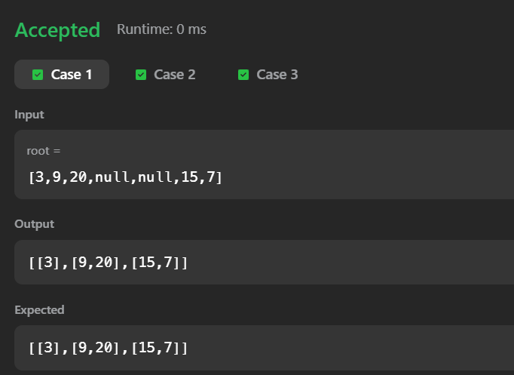
Task 32: Binary Tree Right Side View:
class Solution {
public List<Integer> rightSideView(TreeNode root) {
List<Integer> res = new ArrayList<>();
if (root == null) return res;
Queue<TreeNode> q = new LinkedList<>();
q.offer(root);
while (!q.isEmpty()) {
int size = q.size();
for (int i = 0; i < size; i++) {
TreeNode node = q.poll();
if (i == size - 1) {
res.add(node.val);
}
if (node.left != null) q.offer(node.left);
if (node.right != null) q.offer(node.right);
}
}
return res;
}
}

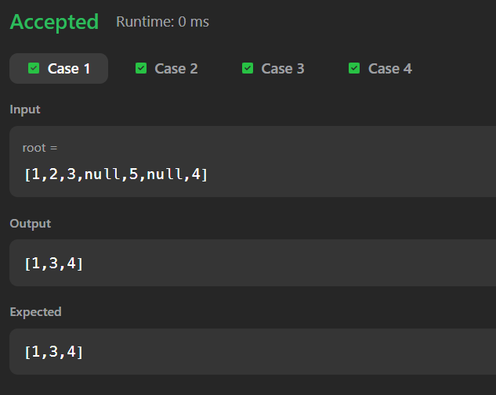
Task 33: Design Circular Queue:
class MyCircularQueue {
int[] q;
int front, rear, size, capacity;
public MyCircularQueue(int k) {
capacity = k;
q = new int[k];
front = 0;
rear = -1;
size = 0;
}
public boolean enQueue(int value) {
if (isFull()) return false;
rear = (rear + 1) % capacity;
q[rear] = value;
size++;
return true;
}
public boolean deQueue() {
if (isEmpty()) return false;
front = (front + 1) % capacity;
size--;
return true;
}
public int Front() {
if (isEmpty()) return -1;
return q[front];
}
public int Rear() {
if (isEmpty()) return -1;
return q[rear];
}
public boolean isEmpty() {
return size == 0;
}
public boolean isFull() {
return size == capacity;
}
}

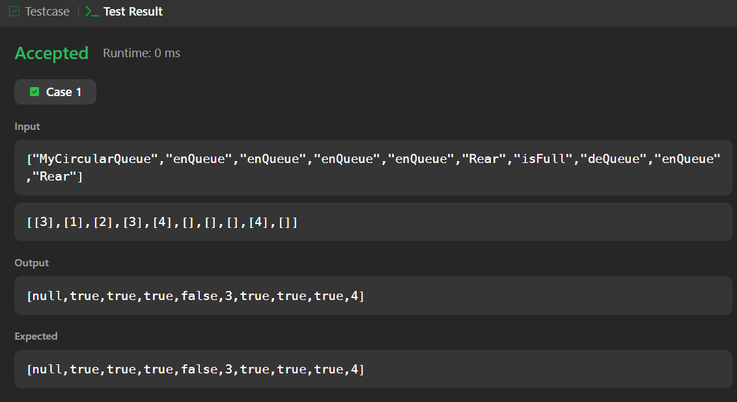

Task 34: Design Circular Deque:
class MyCircularDeque {
int[] dq;
int front, rear, size, capacity;
public MyCircularDeque(int k) {
capacity = k;
dq = new int[k];
front = 0;
rear = -1;
size = 0;
}
public boolean insertFront(int value) {
if (isFull()) return false;
front = (front - 1 + capacity) % capacity;
dq[front] = value;
size++;
if (size == 1) rear = front;
return true;
}
public boolean insertLast(int value) {
if (isFull()) return false;
rear = (rear + 1) % capacity;
dq[rear] = value;
size++;
if (size == 1) front = rear;
return true;
}
public boolean deleteFront() {
if (isEmpty()) return false;
front = (front + 1) % capacity;
size--;
return true;
}
public boolean deleteLast() {
if (isEmpty()) return false;
rear = (rear - 1 + capacity) % capacity;
size--;
return true;
}
public int getFront() {
if (isEmpty()) return -1;
return dq[front];
}
public int getRear() {
if (isEmpty()) return -1;
return dq[rear];
}
public boolean isEmpty() {
return size == 0;
}
public boolean isFull() {
return size == capacity;
}
}

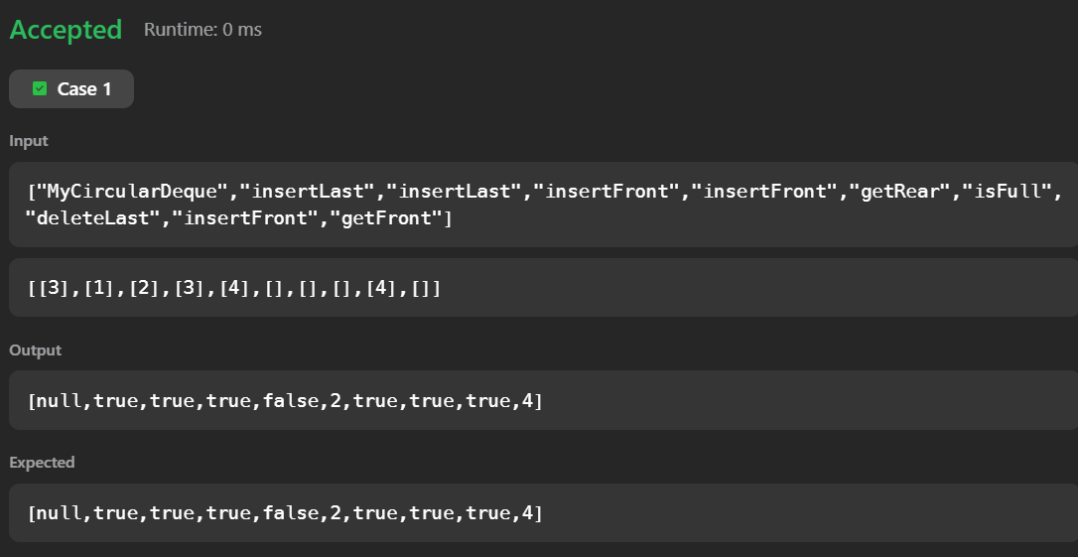
Task 35: Task Scheduler:
class Solution {
public int leastInterval(char[] tasks, int n) {
int[] freq = new int[26];
for (char c : tasks) {
freq[c - 'A']++;
}
int maxFreq = 0;
for (int f : freq) {
maxFreq = Math.max(maxFreq, f);
}
int countMax = 0;
for (int f : freq) {
if (f == maxFreq) countMax++;
}
int partCount = maxFreq - 1;
int partLength = n + 1;
int minTime = partCount * partLength + countMax;
return Math.max(tasks.length, minTime);
}
}
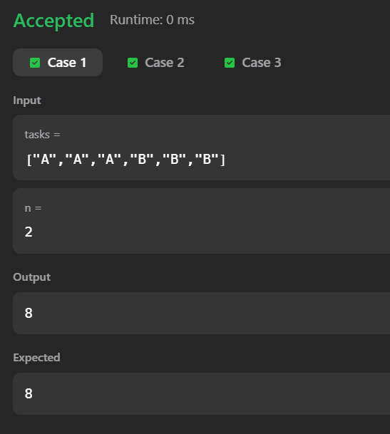

Task 36: Number of Recent Calls:
class RecentCounter {
Queue<Integer> q;
public RecentCounter() {
q = new LinkedList<>();
}
public int ping(int t) {
q.offer(t);
while (q.peek() < t - 3000) {
q.poll();
}
return q.size();
}
}
